Lesson 73 and 74

Why We Need Git Stash

<https://www.canva.com/en_gb/login/?redirect=%2Fdesign%2FDAEPsQa6BFE%2FuNs08sHSGN1XziSUt1BLHQ%2Fview>

I made some commit and switch over to new branch

I switched to a new branch called puppy work. My work is not commit yet

Quick example

This is done on master branch.

I haven’t stage it nor commit and I need to check something inside master branch.

Because I didn’t commit it.

If I merge now it will be fastforward

This is added inside the master.

Now I need to switch back to my goodbye branch

Usually the file would have come with me but unfortunately it didn’t because I have also modified the same file in master and even the same line has been modified therefore it will not allow me to switch.

Lesson 75

Stashing Basics: Git Stash Save & Pop

https://git-scm.com/docs/git-stash

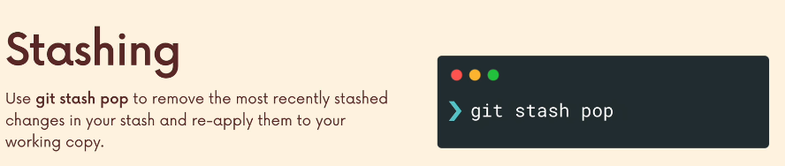

Lesson 76

Practising With Git Stash

I am inside goodbye branch

Now I need to switch to master

I don’t want to take this file with me when switching the branch and moreso they conflicts. Because I have information on html on master branch.

Now I want to stash them.

Now I can switch to any branch of my choice. I will go to master now and remember it was like I cant switch because it will conflicts.

Now in master

Just showing.

I can switch to any branch that I want to apply the changes to and unstash it.

Lesson 77

Git Stash Apply

I might not need it 90%

I haven’t added or committed them.

Because I have stash the changes all the css is gone.

I am on master

I want the changes to come here.

Not if I use git stash pop that will be gone from the save. When I used git stash apply, I still have the files inside the stash.

This is good if you want to apply to multiple branches.

Lesson 78

Working With Multiple Stashes

No style.

Stashing multiple does not make sense.

WIP mean work in progress.

Will try stash 1 now.

I got problem. Its unstaged. I need to get rid of the css

Lesson 79

Dropping & Clearing The Stash

When you do this you’re not cleaning out the stash

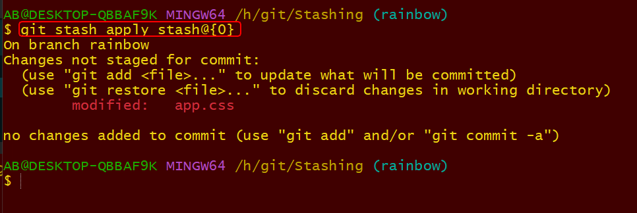

I don’t need the stash any more

Lesson 80

Stashing exercise

<https://plum-poppy-0ea.notion.site/Stashing-Exercise-b6b4ac460c0a4798845de177fc1eb86d>

Date Friday 22/03/2024

